1. Programming Introduction
   1. Operating System Basics
      1. System folders

<https://en.wikipedia.org/wiki/Special_folder>

<https://en.wikipedia.org/wiki/Unix_filesystem#Conventional_directory_layout>

* + 1. System parameters

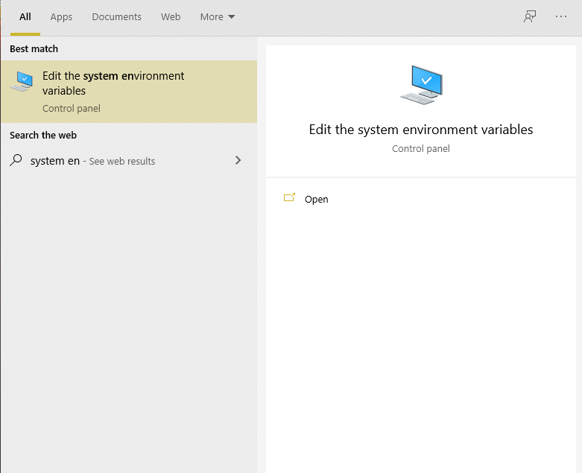

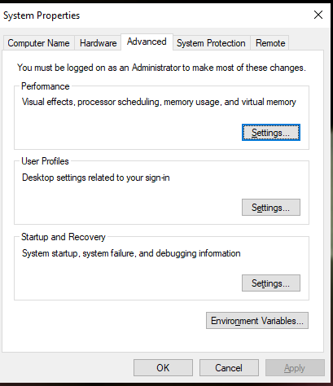

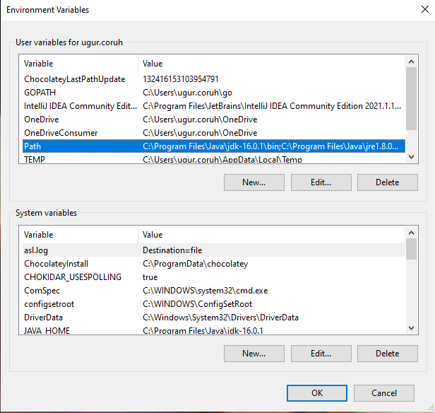

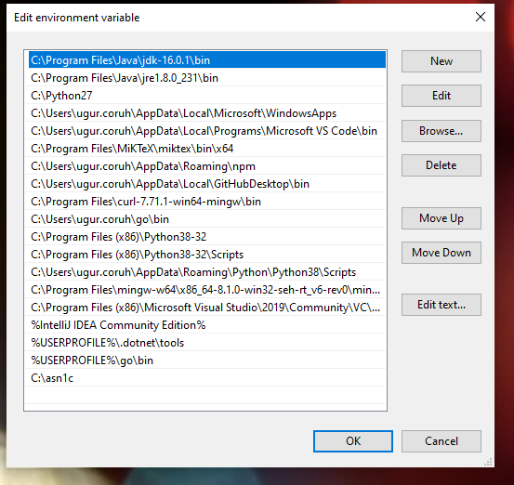

Msconfig -> Configure System

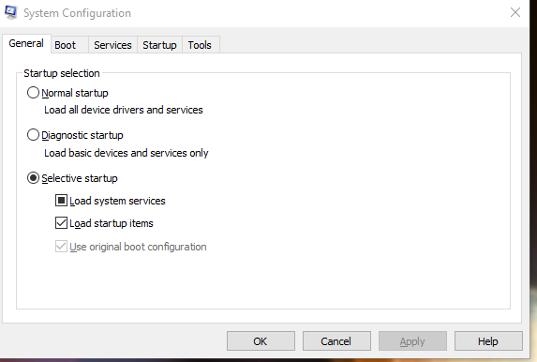

Services.msc

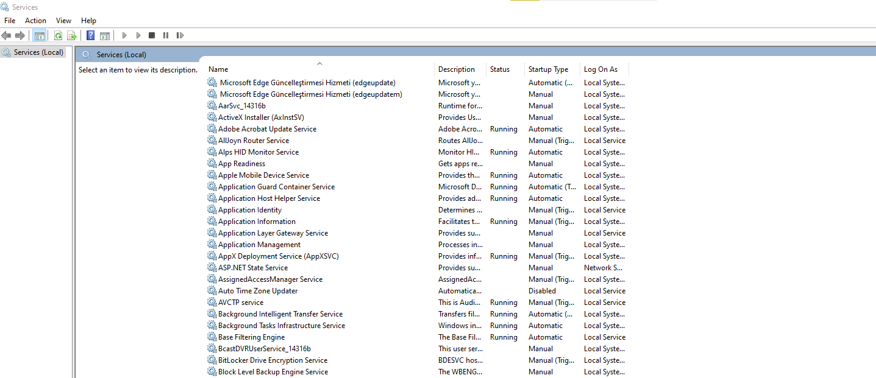

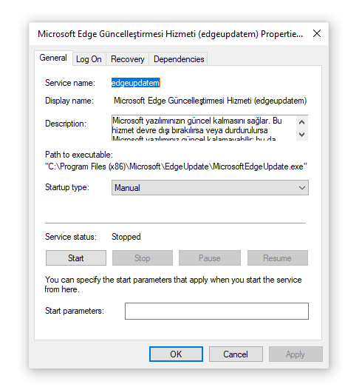

* + 1. Storage management

This PC -> Manage

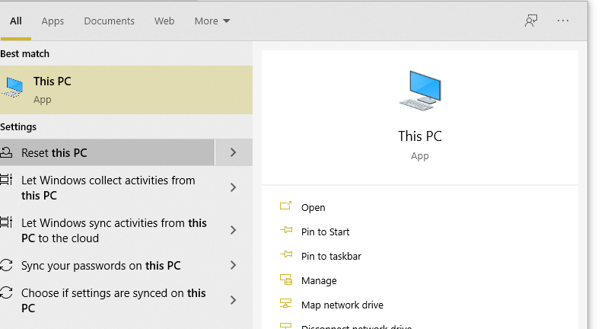

Task Scheduler

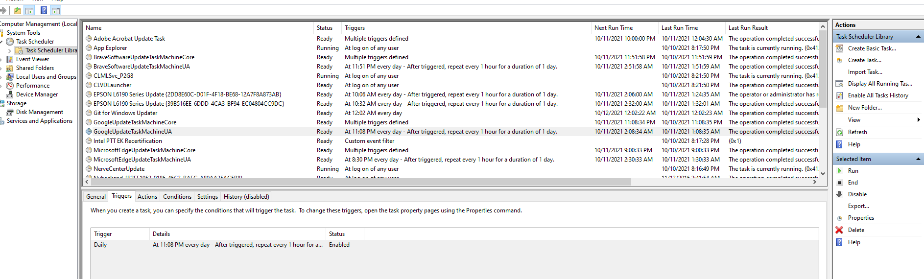

* 1. Computer Network Basics
  2. IP, Port, DNS settings, NAT etc.
  3. Remote connections (FTP, SSH, RDP, XRDP)
  4. Putty, Mobaxterm

1. Numerical System Basics
   * + 1. Binary system
       2. Hexadecimal system
   1. Character Sets
2. Algorithm Basics
3. Introduction to Analysis of Algorithms
   1. Algorithm Basics
   2. Flowgorithm
   3. Pseudocode
4. Programming Topics
5. Sysinternals Utilities
   1. Programming Environment Setup and Configuration
      1. C / Cpp
         1. DevCpp
         2. Code Blocks
         3. GCC/G++ Compiler (Mingw) / Clang-cl (LLVM)
         4. Vscode
            1. GCC
            2. CLANG
         5. Visual Studio Community Edition
            1. Visual Studio x64 x86 Configurations and Features
            2. Project Types
         6. Notepad++
         7. Vi/Vim
         8. Eclipse
            1. Simple Java Project Generation
            2. Jar Export as Library or Executable
            3. Maven Project Generation
            4. Junit Test Case Generation and Testing
         9. Netbeans
         10. Turbo C
         11. Turbo C++

C:\TURBOC3\Turbo C++

<https://developerinsider.co/download-turbo-c-for-windows-7-8-8-1-and-windows-10-32-64-bit-full-screen/>

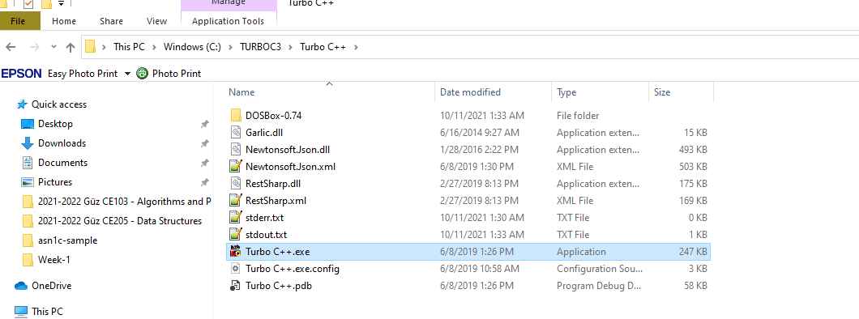

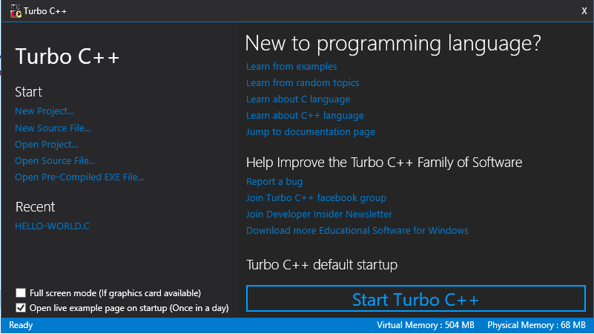

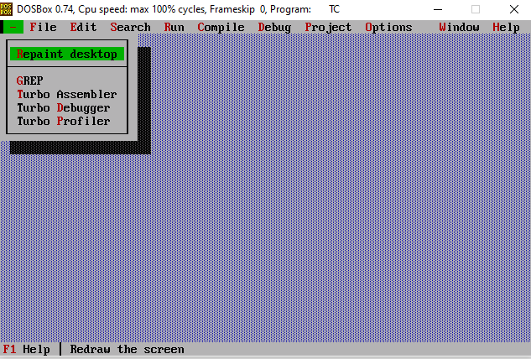

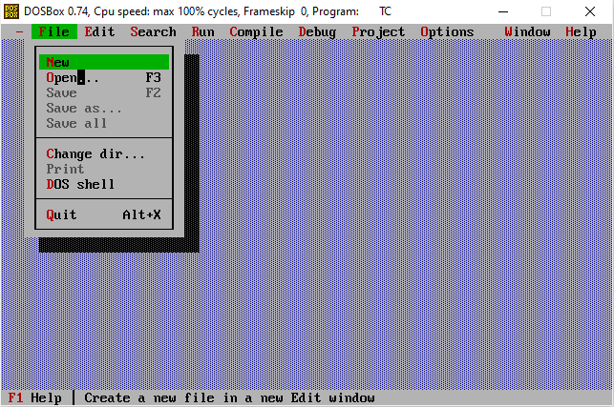

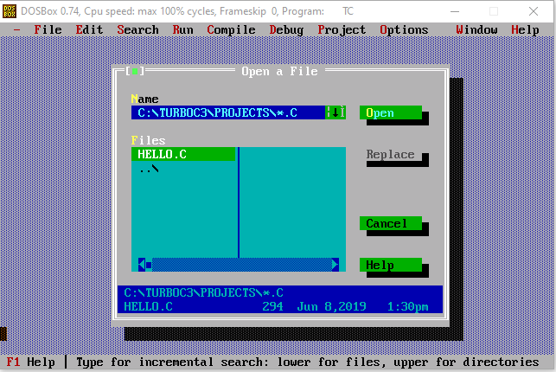

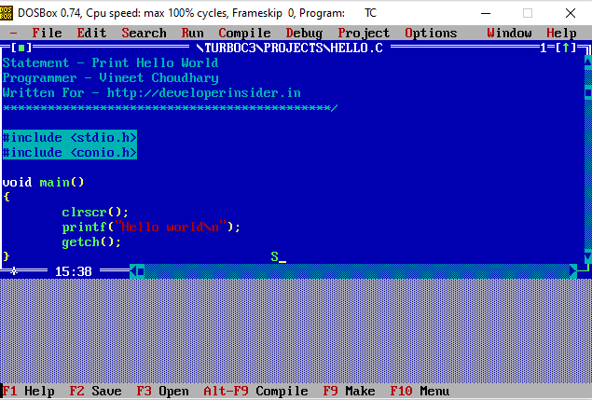

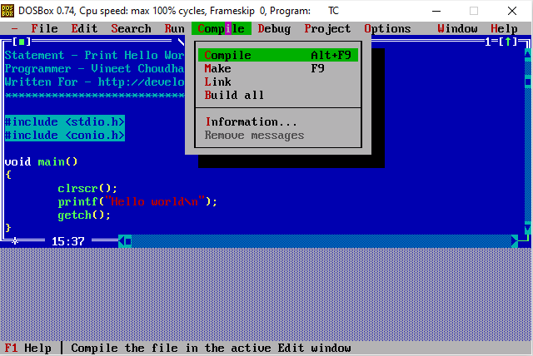

Then just Run from Menu

* + 1. Java
       1. JDK, JRE Setup
       2. System Environments and Paths
       3. Netbeans
       4. Eclipse
       5. Intellij Idea (jetbrains)
       6. vscode
       7. Notepad++
    2. C#
       1. Visual Studio Community Edition
       2. Notepad++
  1. Programming Environment Setup and Configuration
     1. Notepad++ (Notepad for Source Code)
     2. HxD (Hex Editor)
     3. Marktext (Markdown Syntax Editor)
     4. Cygwin (Linux environment for Windows)
     5. Dependency Walker (32-bit or 64-bit Windows module dependency checker)
     6. Doxygen (Code Documentation)
     7. Sonarlint (Code Quality and Code Security Extension)
     8. Codepen.io (online code sharing)
     9. Codeshare.io (real time code sharing)
     10. Codebeautify.org (online data conversion tools)
     11. AsciiFlow.com (ASCII drawing tool)
     12. Freemind (opensource mindmap application)
     13. Wireflow (user flow designer)
     14. PlantUML (software designer)
     15. Drawio (drawing tool)
     16. Putty (Remote Connection)
     17. MobaXterm (Remote Connection)
     18. Teamviewer (Remote Connection)
     19. Paletton.com (Color Chooser)
     20. Understand (Static Code Analysis)
     21. JD Project (Java Decompiler)
     22. Cutter (Multi-Platform Reverse Engineering Tool)
     23. IDA Pro / Freeware (Native Reverse Engineering Tool)
     24. Travis-CI
         1. Travis.yml
     25. Jenkins
     26. Valgrind
     27. Docker
         1. Dockerfile
         2. DockerHub
         3. Docker Compose Yaml
         4. Dockerrun.aws.json (AWS)
     28. Nuget Packages
     29. Extras
         1. vim/vim-wim32-installer (windows vim installer)
     30. SCV Cryptomanager
     31. Addario CryptoBench
     32. Raymond's MD5 & SHA Checksum Utility
     33. SlavaSoft HashCalc
     34. Portable PGP
  2. Online Programming Envoriments
     1. Hackerrank
     2. CS50 Sandbox
     3. Programiz C Online Complier

